Subnetting

1. A subnetwork or subnet is a logical subdivision of an IP network.
2. The practice of dividing a network into two or more networks is called subnetting.
3. Computers that belong to a subnet are addressed with an identical most-significant bit-group in their IP addresses.

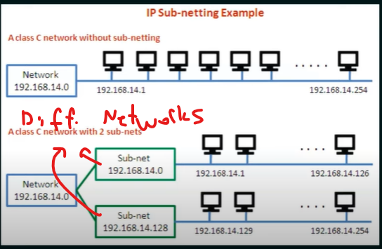

Computers in subnet1 can't communicate with computers in subnet2 with switches because they are not in the same network. They need to use a router to communicate.

Subnetting - 5 steps

1. Identify the class of the IP address and note the default subnet mask.
2. Convert the Defulat subnet mask into binary
3. Note the number of hosts required per subnet and find the subnet generator (SG) and octet position.
4. Generate the new subnet mask.
5. Use the SG and generate the network ranges (subnets) in the appropriate octet position.

